**Java Web开发**

**实验五**

**作业报告**

|  |  |
| --- | --- |
| 学 院 | 计算机 |
| 所在系 班 级 | 2017软件工程系8班 |
| 学 号 姓 名 | 胡加劲 |
| 指 导 教 师 | 郭晓燕 |
| 完 成 时 间 | 4.1 |

# 实验题目

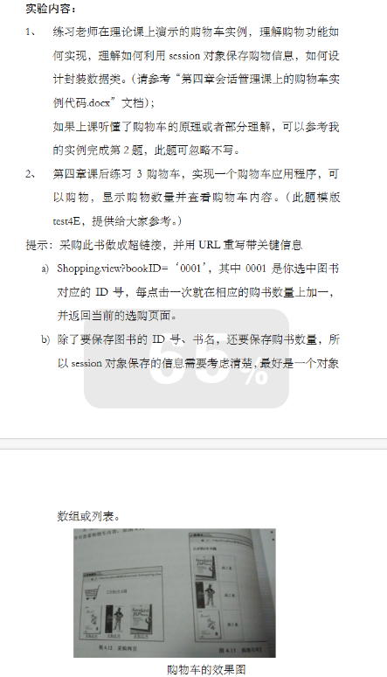

# 分析与设计

分析：是获取到用户所点击的书号，同时从Session

对象中将图书数组取出来。在图书数组中进行遍历，找到和用户点击ID号相同的那本图书，将其购买数量+1，同时将总本数+1，最后将更新好的图书数组和总本数放回session对象中，对应的key不变。

# 关键源码（部分）

<%@ page language=*"java"* contentType=*"text/html; charset=UTF-8"*

pageEncoding=*"UTF-8"*%>

<!DOCTYPE html PUBLIC "-//W3C//DTD HTML 4.01 Transitional//EN" "http://www.w3.org/TR/html4/loose.dtd">

<html>

<head>

<meta http-equiv=*"Content-Type"* content=*"text/html; charset=UTF-8"*>

<title>step-1.jsp</title>

</head>

<body>

<h4>Step1:选择要购买的图书</h4>

<form action=*"*<%= request.getContextPath() %>*/processStep1"* method=*"post"* >

<table border=*"1"* cellpadding=*"10"* cellspacing=*"0"*>

<tr>

<td>书名</td>

<td>购买</td>

</tr>

<tr>

<td>Java</td>

<td><input type=*"checkbox"* name=*"book"* value=*"Java"*/></td>

</tr>

<tr>

<td>Oracle</td>

<td><input type=*"checkbox"* name=*"book"* value=*"Oracle"*/></td>

</tr>

<tr>

<td>Struts</td>

<td><input type=*"checkbox"* name=*"book"* value=*"Struts"*/></td>

</tr>

<tr>

<td colspan=*"2"* >

<input align=*"center"* type=*"submit"* value=*"Submit"*/>

</td>

</tr>

</table>

</form>

</body>

<%@ page language=*"java"* contentType=*"text/html; charset=UTF-8"*

pageEncoding=*"UTF-8"*%>

<!DOCTYPE html PUBLIC "-//W3C//DTD HTML 4.01 Transitional//EN" "http://www.w3.org/TR/html4/loose.dtd">

<html>

<head>

<meta http-equiv=*"Content-Type"* content=*"text/html; charset=UTF-8"*>

<title>Step-2.jsp</title>

</head>

<body>

<form action=*"*<%= request.getContextPath() %>*/processStep2"* method=*"post"*>

<h4>step2: 请输入寄送的地址和信用卡信息</h4>

<table border=*"1"* cellpadding=*"10"* cellspacing=*"0"*>

<tr>

<td colspan=*"2"* align=*"center"*>寄送信息</td>

</tr>

<tr>

<td>姓名：</td>

<td><input type=*"text"* name=*"name"*/></td>

</tr>

<tr>

<td>寄送地址：</td>

<td><input type=*"text"* name=*"address"*/></td>

</tr>

<tr>

<td colspan=*"2"* align=*"center"*>信用卡信息</td>

</tr>

<tr>

<td>种类：</td>

<td>

<input type=*"radio"* name=*"cardType"* value=*"Visa"*/>Visa

<input type=*"radio"* name=*"cardType"* value=*"Master"*/>Master

</td>

</tr>

<tr>

<td>卡号：</td>

<td><input type=*"text"* name=*"card"*/></td>

</tr>

<tr>

<td colspan=*"2"*>

<input align=*"center"* type=*"submit"* value=*"Submit"*/></td>

</tr>

</table>

</form>

</body>

</html>

<meta http-equiv=*"Content-Type"* content=*"text/html; charset=UTF-8"*>

<title>Insert title here</title>

</head>

<body>

<%

Customer customer = (Customer)session.getAttribute("customer");

String[] books = (String[])session.getAttribute("books");

%>

<table border=*"1"* cellpadding=*"10"* cellspacing=*"0"*>

<tr>

<td>顾客姓名：</td>

<td><%= customer.getName() %></td>

</tr>

<tr>

<td>地址：</td>

<td><%= customer.getAddress() %></td>

</tr>

<tr>

<td>卡号：</td>

<td><%= customer.getCard()%></td>

</tr>

<tr>

<td>卡的类型：</td>

<td><%= customer.getCardType()%></td>

</tr>

<tr>

<td>买的书：</td>

<td>

<%

**for**(String book : books ){

out.print(book);

out.print("<br>");

}

%>

</td>

</tr>

</table>

</body>

</html>

package shop;

import java.io.IOException;

import javax.servlet.ServletException;

import javax.servlet.annotation.WebServlet;

import javax.servlet.http.HttpServlet;

import javax.servlet.http.HttpServletRequest;

import javax.servlet.http.HttpServletResponse;

/**

* Servlet implementation class ProcessStep1Servlet

*/

@WebServlet("/processStep1")

public class ProcessStep1Servlet extends HttpServlet {

private static final long serialVersionUID = 1L;

protected void doPost(HttpServletRequest request, HttpServletResponse response) throws ServletException, IOException {

//1.获取选中的图书的信息

String[] books = request.getParameterValues("book");

//2.把图书信息放入到HttpSession 中

request.getSession().setAttribute("books", books);

//3.重定向到shoppingcart/step-2.jsp

response.sendRedirect(request.getContextPath() + "/step-2.jsp");

}

}

package shop;

import java.io.IOException;

import javax.servlet.ServletException;

import javax.servlet.annotation.WebServlet;

import javax.servlet.http.HttpServlet;

import javax.servlet.http.HttpServletRequest;

import javax.servlet.http.HttpServletResponse;

import javax.servlet.http.HttpSession;

import shop.Customer;

/**

* Servlet implementation class ProcessStep2Servlet

*/

@WebServlet("/processStep2")

public class ProcessStep2Servlet extends HttpServlet {

private static final long serialVersionUID = 1L;

protected void doPost(HttpServletRequest request, HttpServletResponse response) throws ServletException, IOException {

//1. 获取请求参数 name ,address ,cardType,card

request.setCharacterEncoding("UTF-8");

String name = request.getParameter("name");

String address = request.getParameter("address");

String cardType = request.getParameter("cardType");

String card = request.getParameter("card");

Customer customer = new Customer(name, address, cardType, card);

//2.把请求存储到Httpsession中

HttpSession session = request.getSession();

session.setAttribute("customer", customer);

//3.重定向到confirm.jsp

response.sendRedirect(request.getContextPath() + "/confim.jsp");

}

}

**package** shop;

**public** **class** Customer {

**private** String name;

**private** String address;

**private** String cardType;

**private** String card;

**public** String getName() {

**return** name;

}

**public** **void** setName(String name) {

**this**.name = name;

}

**public** String getAddress() {

**return** address;

}

**public** **void** setAddress(String address) {

**this**.address = address;

}

**public** String getCardType() {

**return** cardType;

}

**public** **void** setCardType(String cardType) {

**this**.cardType = cardType;

}

**public** **void** setCard(String card) {

**this**.card = card;

}

**public** String getCard() {

**return** card;

}

**public** Customer(String name, String address, String cardType, String card) {

**super**();

**this**.name = name;

**this**.address = address;

**this**.cardType = cardType;

**this**.card = card;

}

**public** Customer() {

**super**();

}

}

# </html>运行效果图

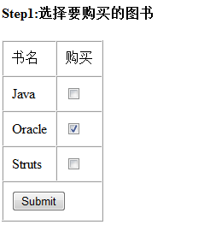

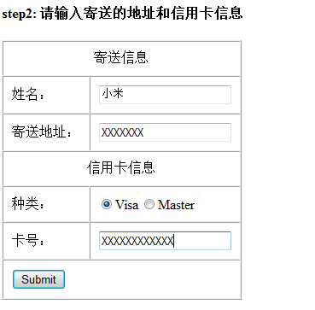

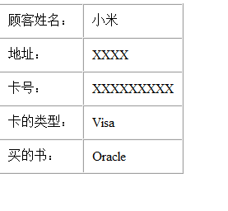

# 收获与问题

可以用session.getAttribute()和session.setAttribute()方法获取和保存会话的数据